1. a) What is metamorphosis? (1mk)

b) What is the biological significance of metamorphosis to an insect? (2mk)

1. a) The diagram below shows a certain plant.

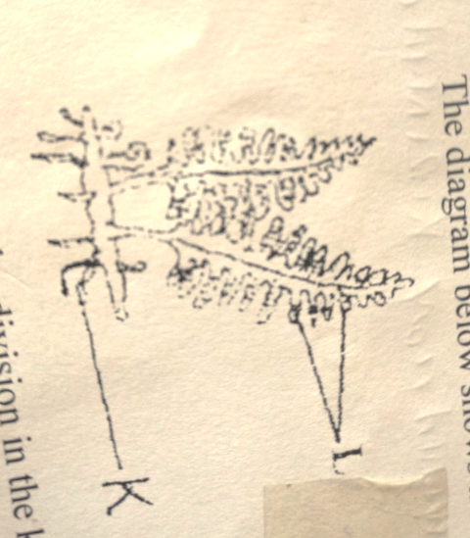

**L**

**K**

1. Name the division in the kingdom plantae to which the plant belongs. (1mk)
2. State the functions of structure labelled K and L. (2mks)
3. Name the type of mutation represented below. (1mk)
4. Original strand
5. mutated strand

__________________ ___________________

A B C D E F P B C D E F

(i) (ii)

1. Name the organelles that perform the following function in a cell.
2. Protein synthesi (1mk)
3. Transport of cell secretions 1mk)
4. The diagram below shows part of alimentary canal of a mammal

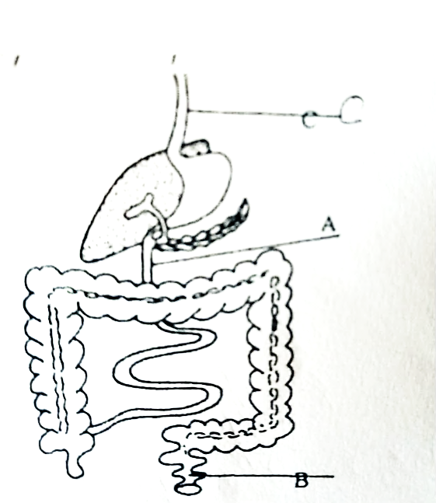

**C**

**A**

**B**

**A**

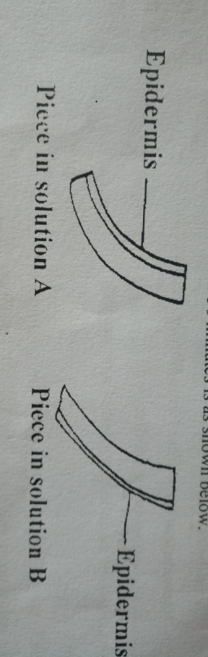

1. Name the parts labeled A and C. (2mks)

A

C

1. State the function of the part labeled B. (1mk)
2. A 4cm straight piece from a herbaceous plant was split lengthwise into two similar pieces. The pieces were placed in sugar solutions of different concentrations for 30 minutes. Their appearance after 30 minutes is as shown below.

Account for appearance of the pieces in solution A and B. (3mks)

1. The equation below represents a process that takes place in plants. (1mk)

6H2O + 6CO2 C6 H12 O6 + 6O2

1. Name the process. (1mk)
2. State two factors not shown in the equation that are necessary for the process to take place. (2mks)
3. a) State two ways in which root hairs are adapted to their functions. (2mks)

b) Explain how high humidity affects the rate of transpiration. (2mks)

1. The diagram below shows the exchange site between circulatory system and body cells.

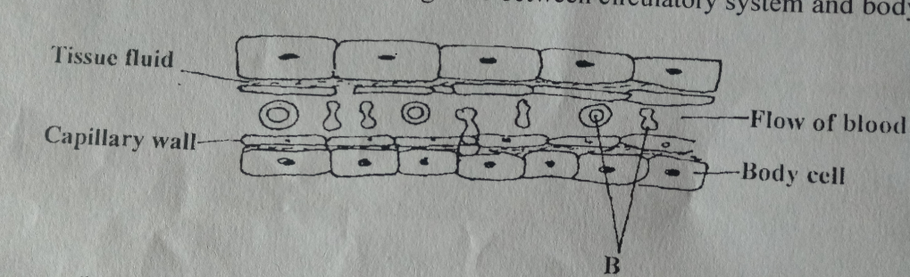

1. Name the cells labelled B. (1mk)
2. Name the gas that diffuses from B to the tissues cells. (1mk)
3. Give two adaptations of the capillary wall. (2mks)
4. State the importance of the following parts of a microscope. (2mks)
5. Clip
6. Coarse adjustment knob
7. The diagram below represents a simplified Nitrogen cycle.

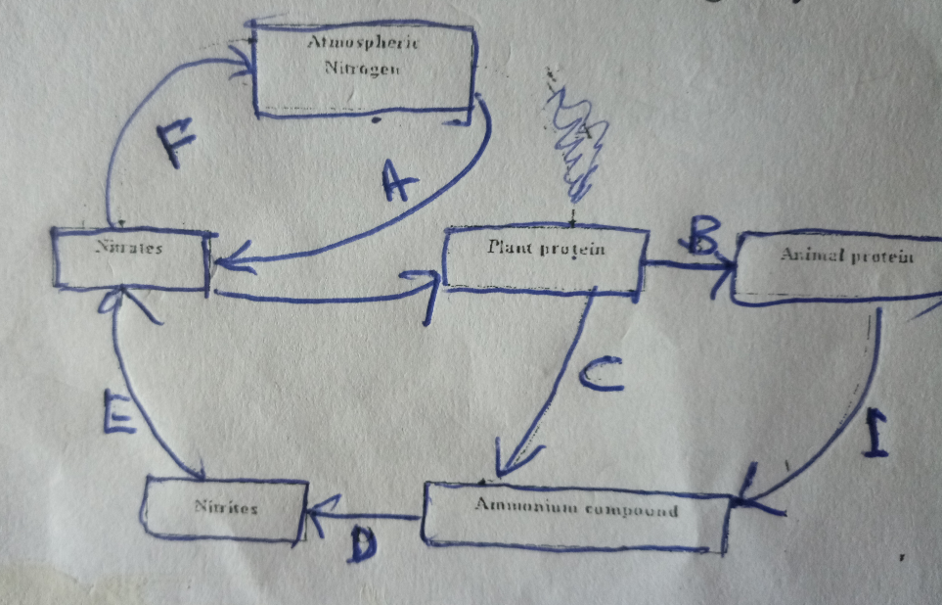

**Atmospheric nitrogen**

**Animal protein**

**Plant proteins**

**Nitrates**

**Ammonium compounds**

**Nitrites**

1. Name the organisms that cause the following process. (3mks)

A

D

E

1. Name the process presented in I above. (1mk)
2. An experiment was done by Form Four students in a certain school on the reaction of growing seedling which was place horizontally in position on a moist cotton wool. After some days, it was observed that the shoots bends upwards while the roots bend downwards.
3. Name the response exhibited by the roots. (1mk)
4. Explain how both bending of the shoots and roots occur. (2mks)
5. The equation below represents a certain process that occurs in plants.

C6H12O6 + substance X Process V lactose + product K

Name the substance x……………………………………… (1mk)

Product k … (1mk)

Process v. (1mk)

1. a) What is meant by the following terms.
2. Homeostasis. (1mk)
3. Osmoregulation. (1mk)

b) Hormones involved in regulating glucose level in blood. (2mks)

1. Give an example of a sex-linked trait in humans on

Y – Chromosome (1mk)

X – Chromosome (1mk)

1. State two disadvantages of sexual reproduction. (2mks)
2. The diagrams below illustrate the organs of some flowering plants.

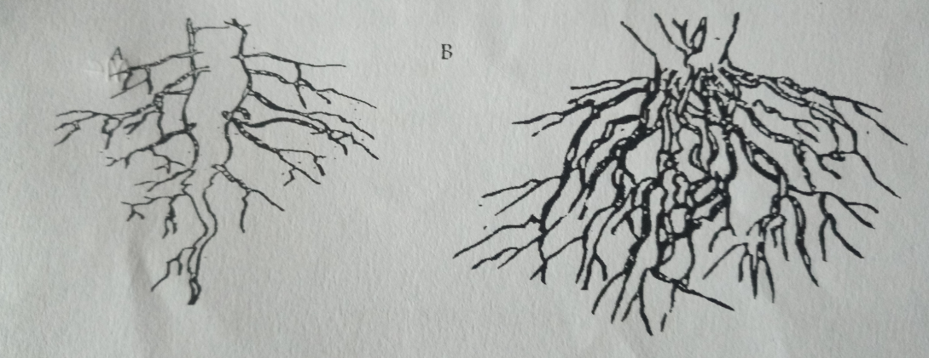

**A**

**B**

State the classes of plants to which each belong. (2mks)

A

B

1. 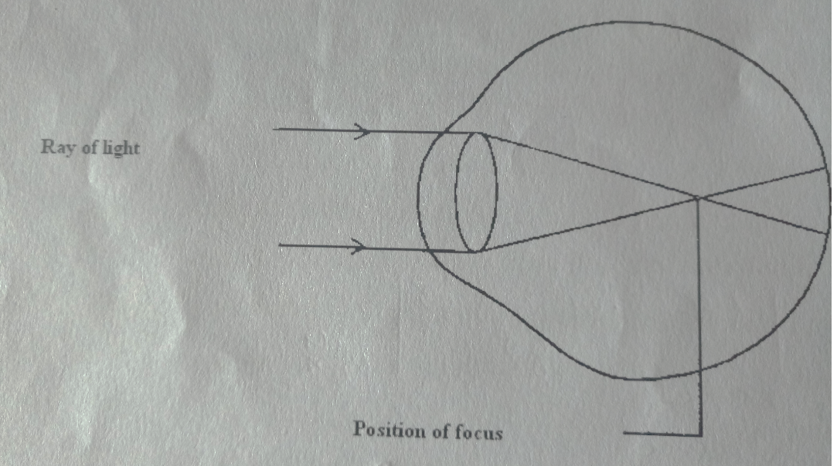The diagram below illustrates a defect in the eye.

**Ray of light**

**Position of focus**

Explain how the defect illustrated above can be corrected. (2mks)

1. The following equation represents aerobic respiration.

6O2 + C6H12O6 6CO2 + 6H2O + Energy

1. Work out the respiratory quotient. (2mks)
2. State the importance of respiratory quotients. (1mk)
3. In humans name the hormone that:
4. Stimulate the contraction of uterus during birth. (1mk)
5. Stimulate development of Graafian follicle. (1mk)

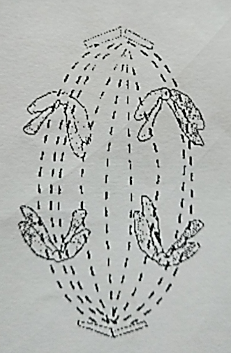

1. The diagram below represents a stage during cell division.
2. Name the stage of cell division. (1mk)
3. Give two reasons for your answer in (a) above. (1mk)
4. a) Name the respiratory surface for gaseous exchange in insects. (1mk)

b) State two adaptations of the site named in (a) above. (2mks)

1. In an experiment, the concentration of ions in the cell sap of reeds growing in a swampy area and the water in the swamp were determined. The data below was obtained. Study it and answer the questions that follow.

|  |  |  |
| --- | --- | --- |
|  | **Concentration of ions in the cell sap** | **Concentration of ions in water in the swamp** |
| Na+  Mg2+ | 60  20 | 30  40 |

1. Name the process by which uptake of the following ions by the reeds occurs. (2mks)
2. State two adaptations of a leaf to gaseous exchange. (2mks)
3. a) The action of pepsin stops in the duodenum. Explain. (2mks)
4. State one function of the muscles found in the alimentary canal of mammals. (1mk)
5. Name the substance produced during anaerobic respiration in animals and state why it should be got rid of immediately. (2mks)

Substance

Reason

1. a) Wing of an insect, wing of a bird, hand of a man, flipper of a whale, foreleg of a horse are locomotory structures in animals. Using the structures listed above state the ones considered as
2. homologous structures (1mk)
3. analogous structures (1mk)

b) Identify the type of evolution that brings about

i) Homologous structures. (1mk)

1. 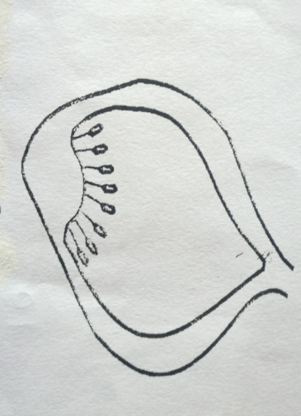a) Identify the type of placentation shown by the diagram below. (1mk)

b) Give two adaptation of a fruit dispersed by water. (2mks)

1. 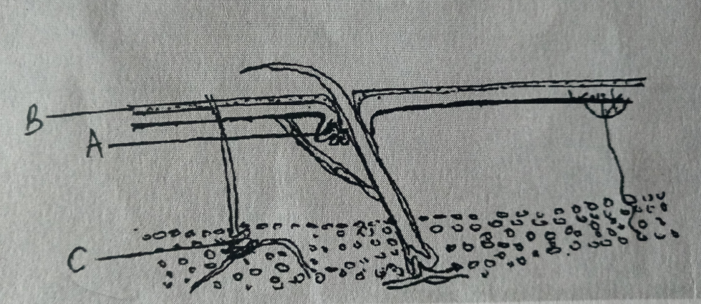The diagram below represents a transverse section through human skin.

**A**

**C**

1. Name the structure labeled A and B (2mks)

**A**

**B**

1. State the function of the parts labeled C. (1mk)
2. State two physiological changes that take place in a human skin in order to facilitate heat loss from the body. (2mks)
3. In what ways are fungal and plant cells similar. (2mks)